Assignment #1



Spring 2022

COMPUTER PROGRAMMING THEORY

Submitted by: MUHAMMAD SADEEQ

Registration No.: 21PWCSE2028

Section: C

"On my honor, as student of University of Engineering and Technology, I have neither given nor received unauthorized assistance on this academic work.'

Submitted to:

Dr. Athar Javed Sethi

(April 22, 2022)

Department of Computer Systems Engineering University of Engineering and Technology, Peshawar

**Assignment 1 (Due Date: 25-04-2022)**

***Note: Write your name and registration number in the assignment***

|  |  |  |  |
| --- | --- | --- | --- |
| **Select lines** | | | **Output** |
| **S2** | **S1** | **S0** | **Out** |
| 0 | 0 | 0 | I0 |
| 0 | 0 | 1 | I1 |
| 0 | 1 | 0 | I2 |
| 0 | 1 | 1 | I3 |
| 1 | 0 | 0 | I4 |
| 1 | 0 | 1 | I5 |
| 1 | 1 | 0 | I6 |
| 1 | 1 | 1 | I7 |

Implement 8 x 1 Digital Multiplexer (MUX), 8 x 1 MUX has eight input lines, one output line and three select lines. The select lines are used to select any one of eight inputs.



8

x

1

MUX

I

0

I

1

I

2

I

3

I

4

I

5

I

6

I

7

out

s

0

s

1

s

2

1-Implement 8X1 Multiplexer using if-else structure.

2-Implement 8X1 Multiplexer using conditional operator.

**Assignment # 1**

**1-Implemented 8X1 Multiplexer using if-else structure.**

**Source code**

#include<iostream>

using namespace std;

int main(){

int s0,s1,s2;

cout<<"\tEnter value for s0 = ";

cin>>s0;

cout<<"\tEnter value for s1 = ";

cin>>s1;

cout<<"\tEnter value for s2 = ";

cin>>s2;

if(s2==0)

{

if(s1==0)

{

if(s0==0)

{cout<<"\tOUTPUT = I0 ";

}

else

{cout<<"\tOUTPUT = I1";

}

}

else

{

if(s0==0)

{cout<<"\tOUTPUT = I2";

}

else

{cout<<"\tOUTPUT = I3";}}}

else

{

if(s1==0)

{

if(s0==0)

{cout<<"\tOUTPUT = I4";}

else

{cout<<"\tOUTPUT = I5";}}

else

{

if(s0==0)

{cout<<"\tOUTPUT = I6 ";}

else

{cout<<"\tOUTPUT = I7 ";}}}

return 0;}

**Output of code**

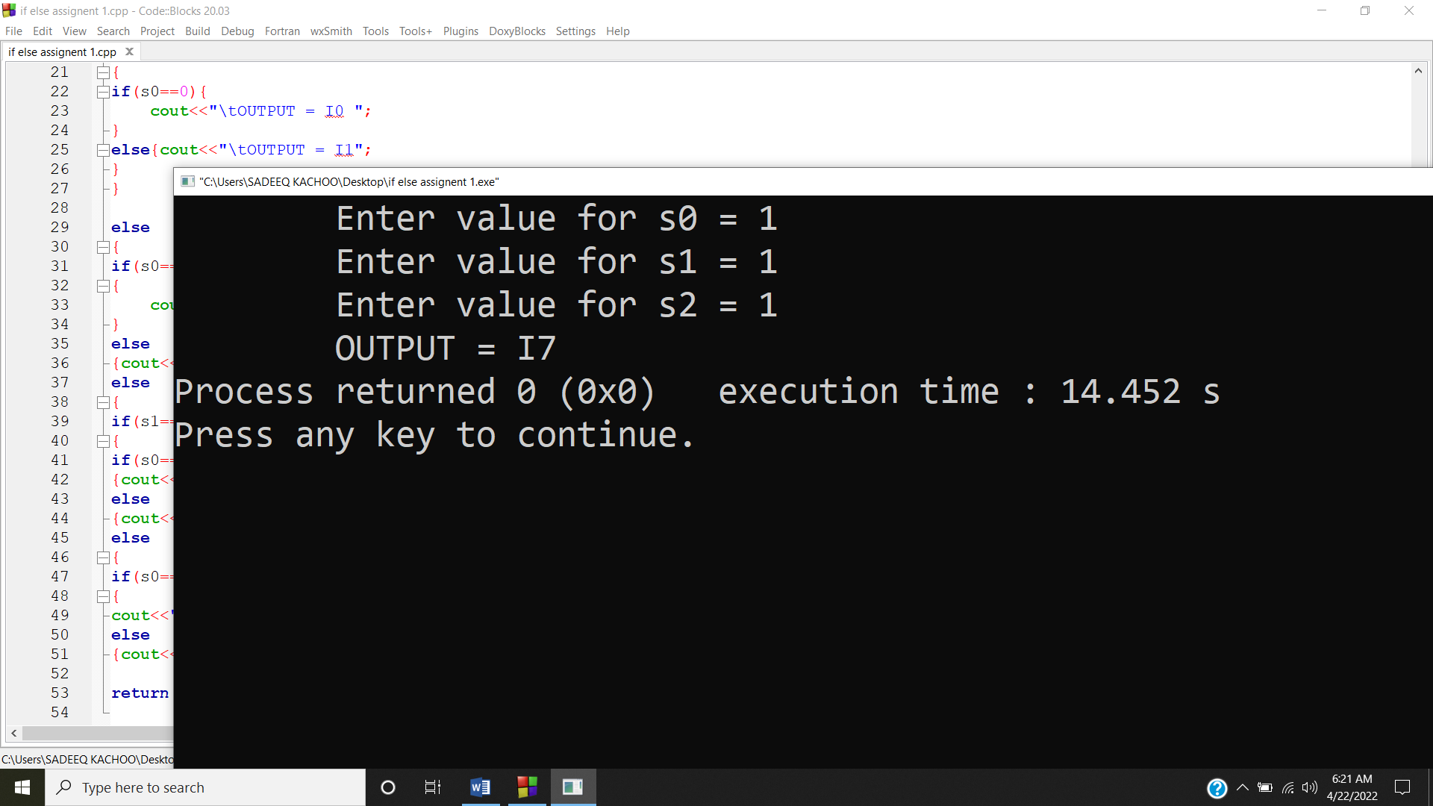

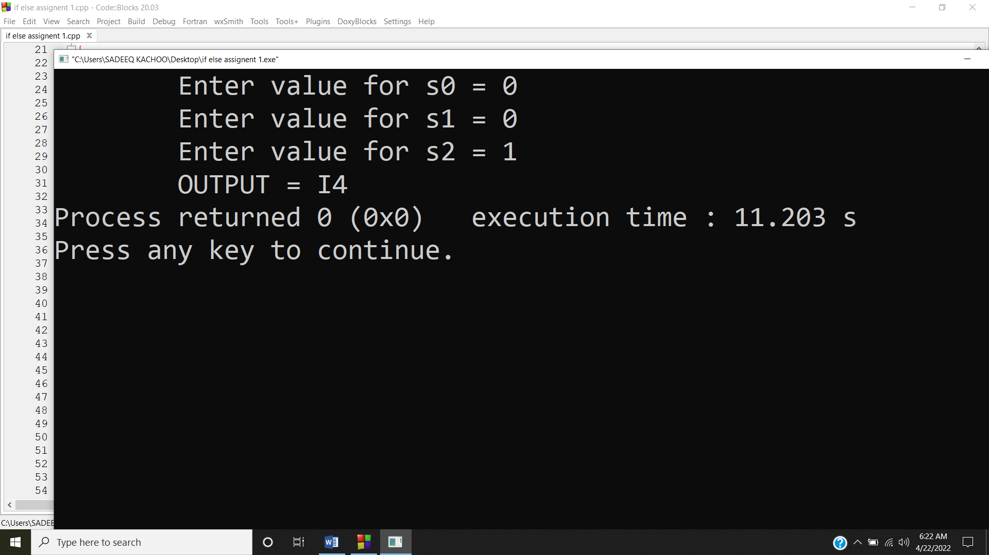

**2-Implement 8X1 Multiplexer using conditional operator.**

**Source code**

#include<iostream>

using namespace std;

int main(){

int s0,s1,s2;

string M_SADEEQ;

cout<<"\tEnter value for s0 = ";

cin>>s0;

cout<<"\tEnter value for s1 = ";

cin>>s1;

cout<<"\tEnter value for s2 = ";

cin>>s2;

M_SADEEQ =(s2==0&&s1==0&&s0==0)

?"\t Output = I0":"";

cout<<M_SADEEQ;

M_SADEEQ =(s2==0&&s1==0&&s0==1)

?"\t Output = I1":"";

cout<<M_SADEEQ;

M_SADEEQ =(s2==0&&s1==1&&s0==0)

?"\t Output = I2":"";

cout<<M_SADEEQ;

M_SADEEQ =(s2==0&&s1==1&&s0==1)

?"\t Output = I3":"";

cout<<M_SADEEQ;

M_SADEEQ =(s2==1&&s1==0&&s0==0)

?"\t Output = I4":"";

cout<<M_SADEEQ;

M_SADEEQ =(s2==1&&s1==0&&s0==1)

?"\t Output = I5":"";

cout<<M_SADEEQ;

M_SADEEQ =(s2==1&&s1==1&&s0==0)

?"\t Output = I6":"";

cout<<M_SADEEQ;

M_SADEEQ =(s2==1&&s1==1&&s0==1)

?"\t Output = I7":"";

cout<<M_SADEEQ;

return 0;}

**Output of code**

